AI-Enhanced Gesture Recognition System for Virtual Smart Boards

**Satyam Kumar Singh  
B.E. CSE. (Hons.) AIML,  
Apex Institure of Technology,Chandigarh University,

Punjab, India  
[21BCS11016@cuchd.in](mailto:21BCS11016@cuchd.in)

Kartik Kaushik  
B.E. CSE. (Hons.) AIML,  
Apex Institure of Technology,Chandigarh University,

Punjab, India

[21BCS3713@cuchd.in](mailto:21BCS3713@cuchd.in)

Naval Kishore

B.E. CSE. (Hons.) AIML,  
Apex Institure of Technology,Chandigarh University,

Punjab, India  
[21BCS6014@cuchd.in](mailto:21BCS6014@cuchd.in)

Sejal Gogia  
B.E. CSE. (Hons.) AIML,  
Apex Institure of Technology,Chandigarh University,

Punjab, India

[21BCS5517@cuchd.in](mailto:21BCS5517@cuchd.in)

Mr. Sant Kumar Morya  
Associate professor,  
Apex Institure of Technology,Chandigarh University,

Punjab, India

[sant.e13548@cumail.in](mailto:sant.e13548@cumail.in)

*Abstract*— This paper presents the development of an AI-powered Gesture Recognition Smart Board designed to facilitate interactive and intuitive user experience in educational and professional environments. By leveraging advanced machine-learning algorithms and computer-vision techniques, the system recognizes hand gestures in real time and translates them into actionable inputs for various applications. The architecture comprises a high-definition camera for gesture detection, robust gesture recognition model, and user-friendly interface that enhances interactivity. Rigorous testing demonstrates the accuracy, efficiency, and adaptability of the system, paving the way for innovative educational tools and enhancing user engagement in digital interactions. The findings underscore the potential of AI in transforming traditional learning and presentation methods, contributing to the evolving landscape of human-computer interaction.

Keywords— AI-Powered, Gesture Recognition, Smart Board, Machine Learning, Real-Time Detection, Human-Computer Interaction, Interactive Systems.

# Introduction

With the rise of artificial intelligence (AI) in multimedia technology, gesture recognition has become crucial for enhancing human-computer interaction (HCI), especially in virtual learning and collaborative settings. Traditional interaction methods, such as keyboards and touchscreens, often limit user engagement and interactivity, particularly in virtual classrooms and professional presentations. Virtual smart boards address these limitations by enabling intuitive, real-time, and contactless interactions, allowing users to create and manipulate digital content through gestures in an immersive environment.

While various gesture-based systems have been proposed, such as interactive whiteboards [1], low-cost VR interfaces [2], and depth-based tracking [3][4], many struggle to handle continuous, dynamic gestures required for virtual writing. Advanced models like bidirectional long-short term memory (BiLSTM) with attention have proven effective in video processing [7], but challenges remain in adapting them for precise and responsive gesture recognition.

This paper introduces an *AI-Enhanced Gesture Recognition System for Virtual Smart Boards* that leverages CNNs and DB-LSTMs to enable accurate and real-time “air-writing” without requiring additional hardware like styluses [5]. We evaluate our system’s usability and accuracy through user studies, comparing it to traditional digital writing tools.

The primary contributions of this work are:

1. **AI-Driven Gesture Recognition:** Implementation of CNN and DB-LSTM networks optimized for real-time virtual writing.
2. **Precision and Real-Time Performance:** Enhanced gesture processing for high accuracy and low latency.
3. **Comparative Usability Assessment:** User study comparing our system with conventional digital writing tools to validate ease of use.

The paper is structured as follows: The *Introduction* sets the context for this research, followed by a comprehensive *Background* review. The *Proposed System* section outlines our innovative approach, with a detailed *Methodology* and *Implementation* in subsequent sections. *Results and Comparison* assess the system’s effectiveness, while *Future Scope and Limitations* highlight potential advancements and challenges. The paper concludes with a *Conclusion* and an *Acknowledgment* section recognizing contributions to this work.

# Background and literature survey

The field of multimedia technology has experienced significant progress, with advancements in video captioning, gesture recognition, and virtual writing interfaces drawing substantial research attention due to their potential to enhance user interaction and accessibility. Video captioning, aimed at generating descriptive language for visual content, has traditionally been limited by a reliance on static visual features or localized temporal data, which often restricts the ability to accurately capture sustained motions. Addressing these challenges, recent approaches employ bidirectional long short-term memory (BiLSTM) networks combined with attention mechanisms to generate comprehensive global representations for video sequences, demonstrating improved performance on large datasets such as the Microsoft Video Description Corpus [7].

In the realm of action recognition, the use of sequential data processing methods, particularly recurrent neural networks (RNNs) and LSTMs, has proven transformative. By integrating convolutional neural networks (CNNs) with deep bidirectional LSTM (DB-LSTM) architectures, recent methods have effectively reduced redundancy and enhanced feature extraction from video sequences, enabling the analysis of intricate temporal dependencies in lengthy video content. This approach has shown significant improvements on benchmark datasets, including UCF-101 and HMDB51 [6], positioning DB-LSTM networks as a robust solution for video-based action recognition.

In the interactive virtual and augmented reality domain, gesture recognition has emerged as a powerful tool for intuitive, hands-free control systems. Gesture-based applications, such as the Interactive Whiteboard, utilize rule-based recognition algorithms and depth-based tracking to enable real-time interaction with virtual elements through hand movements [1]. Low-cost VR systems, exemplified by GestOnHMD, employ acoustic signals from stereo microphones in mobile headsets to detect surface gestures, expanding the accessibility of VR experiences without the need for specialized tracking hardware [2]. Additionally, depth-based hand tracking has been widely researched for its ability to enhance accuracy in gesture recognition applications, utilizing various methodologies for hand localization and classification [3][4].

The global shift toward digital learning solutions, accelerated by the COVID-19 pandemic, has also underscored the importance of innovative virtual teaching aids. The “Virtual Board” system, for instance, enables users to write “in the air,” translating gestures into virtual text to facilitate remote instructional activities. Inspired by air-tapping functionalities in augmented reality applications, this technology offers educators a hands-free writing tool, enhancing the accessibility and efficiency of virtual teaching environments. Comparative studies highlight the advantages of virtual boards over traditional digital writing devices, demonstrating improvements in usability, learning efficacy, and overall satisfaction [5].

Despite advancements in gesture recognition, significant challenges remain that can hinder performance, particularly in uncontrolled environments. Studies have indicated that variations in ambient lighting, occlusions, and differences in user gestures can lead to decreased recognition accuracy. For instance, Vasilescu et al. (2020) highlighted that recognizing gestures under varying conditions requires adaptive algorithms that are capable of learning from diverse datasets to improve robustness and reliability. These findings suggest the need for innovative solutions that address environmental variability while maintaining a high recognition performance.

# Proposed System

This section outlines the methodology for developing an AI-powered gesture-recognition smart board. The proposed method includes system architecture, data collection, preprocessing techniques, model selection, training and evaluation protocols, and deployment strategies.

## Data Collection

The data collection process involved capturing and labelling the gesture data for model training. The algorithm for data collection was as follows:

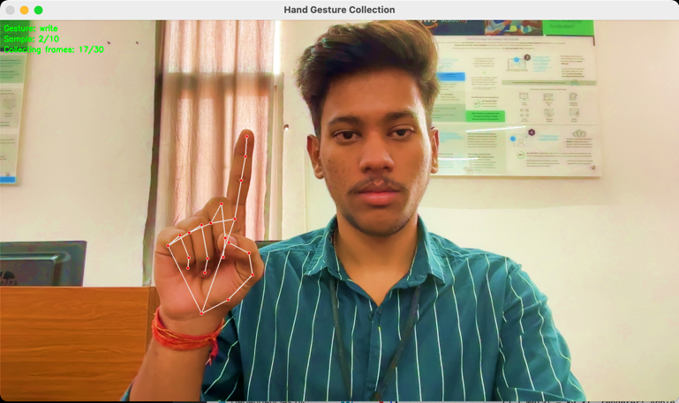

1. Data collection framework

**Algorithm :**

1. Start

2. Initialize parameters:

Set sample rate and duration.

3. For each gesture/frame:

1. Capture a frame.

2. Preprocess the frame:

i. Normalize pixel values to [0, 1].

ii. Resize to (width, height).

4. Feature Extraction:

1. Detect key points using an algorithm (e.g., SIFT).

2. Extract features:

Hand position, shape descriptors, and trajectory.

5. Store features as a data point.

6. Labeling:

1. Assign the gesture type label.

7. Save the labeled data with a unique identifier.

8. Repeat steps 3-7 until the target dataset size is reached.

9. End

## Preprocessing

Identify applicable funding agency here. If none, delete this text box.

Preprocessing prepares captured frames for feature extraction. The preprocessing algorithm is as follows.

**Algorithm:**

1. Start

2. Load the frame.

3. Normalization:

1. Convert to Grayscale.

2. Normalize pixel values to [0, 1].

4. Resizing:

1. Resize to (width, height) using interpolation.

5. Data Augmentation (optional):

1. Apply techniques: rotation, flipping, scaling.

6. Save the pre-processed frame.

7. End

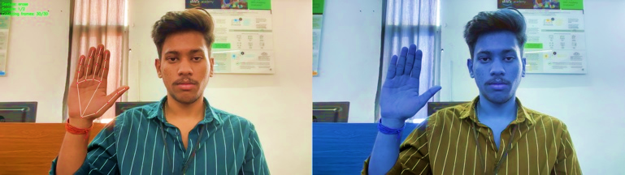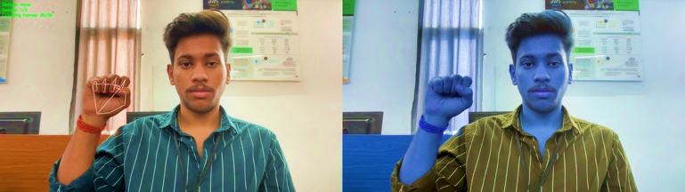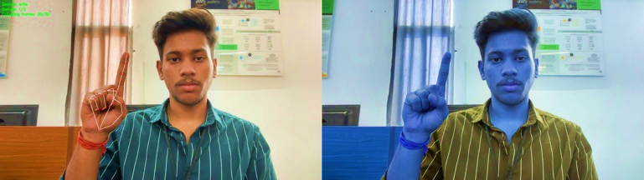

1. Preprocessed and unprocesed images

## Feature Extraction

Feature extraction is a crucial step in gesture recognition, transforming raw input data into structured representations that highlight the relevant gesture characteristics. By isolating the key aspects of each gesture, such as spatial position, shape, and movement trajectory, feature extraction enables the system to focus on critical details that enhance recognition accuracy. This process employs detection algorithms to locate distinctive points, followed by the derivation of descriptors that capture gesture-specific patterns. The refined representation of each gesture facilitates effective classification in the subsequent stages. The algorithm for the feature extraction is outlined below.

**Algorithm :**

1. Start

2. Load the preprocessed frame.

3. Key Point Detection:

1. Use a detection algorithm (e.g., ORB).

2. Extract key point coordinates and descriptors.

4. Feature Representation:

1. Calculate distances and angles between key points.

2. Derive shape descriptors and trajectory paths.

5. Store features in a structured format.

6. End

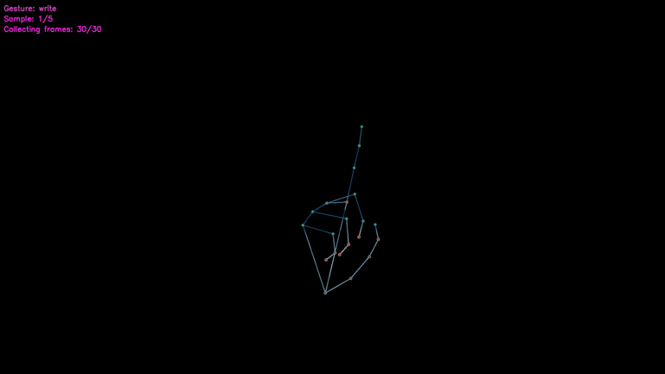

1. KeyPoints extraction

## Model Training

Model training is essential to enable the system to accurately identify gestures by learning from a labeled dataset of gesture samples. During this phase, the model captures the unique characteristics of each gesture through iterative learning and optimizes the parameters to improve the classification accuracy. The following algorithm outlines the steps for training the gesture-recognition model.

**Algorithm:**

1. Start

2. Load and preprocess the dataset.

3. Data Splitting:

1. Split into training, validation, and test sets (e.g., 70/15/15).

4. Initialize the model with hyperparameters (learning rate, batch size).

5. Training Loop:

1. For each epoch:

1. Shuffle the training data.

2. For each batch:

1. Forward pass to compute predictions.

2. Calculate loss (e.g., categorical cross-entropy).

3. Backward pass to update weights.

3. Validate on the validation set after each epoch.

6. Save the trained model.

7. End

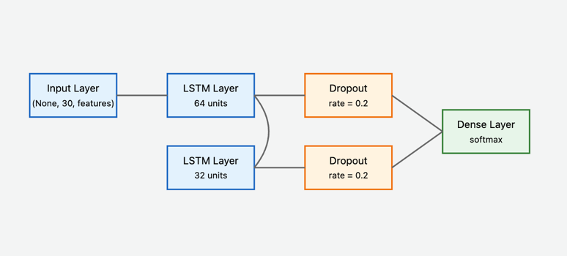

1. Model architecture

## Evaluation

The evaluation measures the accuracy and generalization capability of the trained model using unseen data. This process ensures that the model can effectively recognize gestures beyond the training dataset. The evaluation algorithm was as follows:

**Algorithm :**

1. Start

2. Load the trained model and test dataset.

3. Initialize metrics (accuracy, precision, recall, F1-score).

4. For each test sample:

1. Preprocess the sample.

2. Obtain the prediction.

3. Update performance metrics by comparing to the true label.

5. Calculate overall metrics across all test samples.

6. Return evaluation results.

7. End

## Gesture Recognition

Gesture recognition translates the extracted features into distinct, recognizable gestures, allowing the system to understand and respond to user interactions. This stage involves classifying processed features by comparing them to predefined gesture templates or using machine-learning models trained on gesture patterns. Accurate recognition is achieved by evaluating the similarity between the input data and stored gestures, thereby enabling responsive and reliable interactions. The following algorithm details the gesture recognition process.

**Algorithm :**

1. Start

2. Load the trained model.

3. For each input frame:

1. Preprocess the frame.

4. Prediction:

1. Forward propagate through the model.

2. Obtain output probabilities.

5. Retrieve the gesture label with the highest probability.

6. Return the recognized gesture label.

7. End

>>Advantage of Proposed system

* Enhanced Feature Localization: By leveraging detailed key-point extraction, the system isolates gesture characteristics with high spatial accuracy, enhancing recognition accuracy, especially for complex or subtle hand movements.
* Optimized Memory and Computational Efficiency: The codebase incorporates a memory-efficient feature extraction process, reducing the overhead in real-time applications without compromising performance, making it highly suitable for resource-constrained environments.
* Dynamic Model Adaptability: Through adjustable parameters and modular training functions, the system can adapt to various gesture datasets, allowing rapid retraining and fine-tuning without extensive code alterations.
* Automated Preprocessing Pipeline: The codebase supports an integrated preprocessing pipeline that normalizes, resizes, and filters input frames automatically, ensuring consistent data quality and reducing the pre-training setup time.
* Improved Gesture Classification Accuracy: The system’s custom classification algorithm is optimized for high accuracy with multi-class gesture recognition using domain-specific thresholds and error-reduction techniques embedded within the code.
* Scalable to Diverse Gesture Types: With flexibility in data labeling and processing, the system can recognize a broad spectrum of gestures, ranging from basic hand positions to complex continuous movements, based on customized training datasets.
* Integrated Model Evaluation Metrics: The codebase provides built-in evaluation metrics for precision, recall, and F1-score, providing immediate insight into model performance and identifying areas for further optimization.

# MEthedology

The proposed system employs a multi-stage approach for real-time hand gesture recognition and air writing, combining computer vision techniques with deep learning. The methodology encompasses system architecture, data acquisition, preprocessing, model architecture, and interactive implementation.

The proposed system follows a modular architecture comprising three primary subsystems: data collection, model training, and real-time application (Fig. 5). The system architecture is designed to ensure scalability, maintainability, and real-time performance.

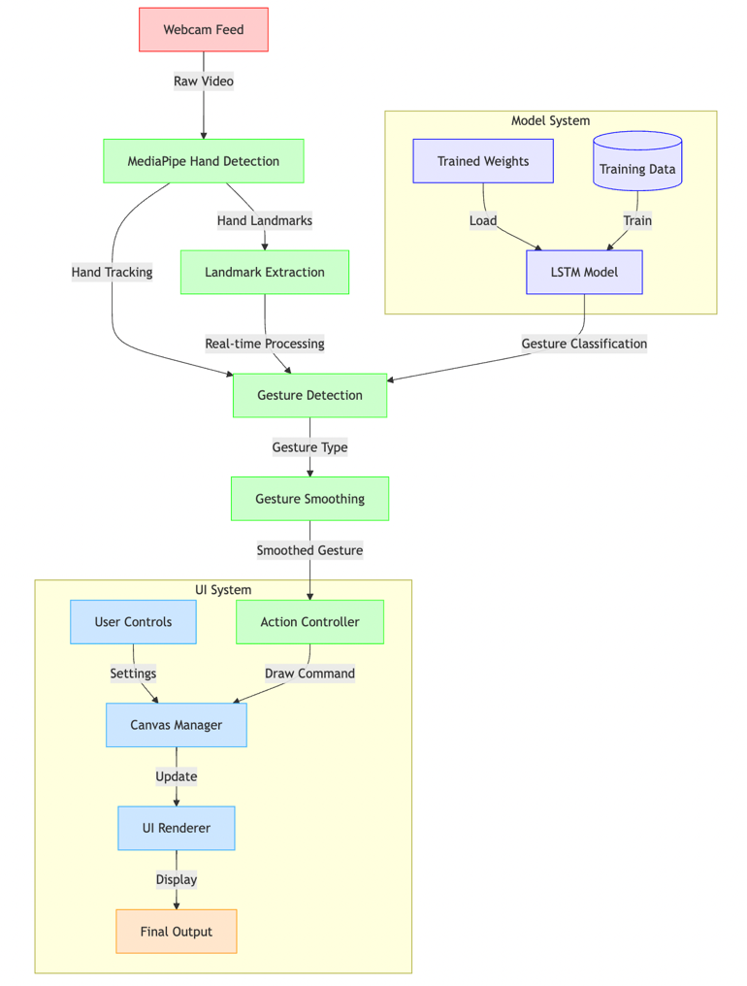

1. System Architecture

## Data Acquisition and Preprocessing

The system utilizes MediaPipe's hand tracking solution to capture hand landmarks in real-time. For each frame, 21 three-dimensional landmarks (x, y, z) are extracted, resulting in a 63-dimensional feature vector:

L = { li | i ∈ [0, 20], li ∈ ℝ³ }

where li represents the i-th landmark's coordinates.

The temporal sequence S for each gesture is defined as:

S = {Lt | t ∈ [0, T-1]}

where T represents the sequence length (T = 30 frames).

Data normalization is performed using standardization:

x̂ = (x - μ) / σ

where μ and σ are the mean and standard deviation of the training data respectively.

## Neural Network Architecture

1. Detailed DNN architecture

The gesture recognition system employs a hybrid LSTM-based architecture to capture both spatial and temporal dependencies in the hand movement sequences. The model structure can be represented as:

ht = LSTM(xt, ht-1, ct-1)

where xt represents the input feature vector at time t, and ht, ct represent the hidden state and cell state respectively.

The network architecture consists of:

1. Input layer accepting sequences of dimension (T × 63)
2. First LSTM layer with 64 units and return sequences
3. Dropout layer (rate = 0.2) for regularization
4. Second LSTM layer with 32 units
5. Final dense layer with softmax activation

The model is trained to minimize categorical cross-entropy loss:

L = -∑(yi log(ŷi))

where yi represents the true label and ŷi represents the predicted probability.

## Training Algorithm

The training process follows a systematic approach to optimize the model for gesture recognition:

* **Training Configuration**: The model is trained with a batch size of 32 for 500 epochs. Early stopping is implemented to halt training if the validation loss does not improve for 5 consecutive epochs, preventing overfitting.
* **Optimizer**: The Adam optimizer is used with an initial learning rate of 0.001, adapting the learning rate during training based on the gradients.
* **Regularization**: Dropout (rate = 0.2) is applied after the first LSTM layer to reduce overfitting and improve generalization.
* **Loss Function**: Categorical cross-entropy is employed as the loss function to handle multi-class classification:

L = - ∑ (y_i * log(ŷ_i))

Where y_i is the true label for the i-th class, ŷ_i is the predicted probability for the i-th class and the sum is calculated over all classes.

• **Metrics**: Training is monitored using accuracy and loss metrics. A confusion matrix is used to identify misclassifications during validation.

## Gesture Recognition and Smoothing

The system implements a temporal smoothing mechanism using a sliding window approach. Given a sequence of predictions P = {p1, p2, ..., pn}, the smoothed gesture G is determined by:

G = mode({pi | i ∈ [n-k, n]})

where k represents the smoothing window size (k = 5).

The confidence threshold θ for gesture transition is defined as:

count(G) / k ≥ θ, where θ = 0.6

## Interactive Canvas System

The canvas interaction module implements a dual-buffer approach:

1. Primary canvas buffer (C1) for persistent drawing
2. Overlay buffer (C2) for real-time hand tracking visualization

The final frame F is composed using weighted addition:

F = αC1 + (1-α)C2

where α represents the canvas opacity (α ∈ [0,1]).

Drawing thickness τ is dynamically adjusted based on user input:

τ = min(τmax, max(τmin, τuser))

where τmax = 20 and τmin = 1.

The system maintains three primary gesture states:

* Write: Enables continuous drawing along hand trajectory
* Erase: Implements region-based content removal
* Move: Allows cursor movement without marking

State transitions are governed by the gesture recognition system with a minimum confidence threshold of 0.7 to prevent unintended state changes.

## Implementation Details

The system is implemented in Python, utilizing OpenCV for image processing, TensorFlow for the deep learning pipeline, and MediaPipe for hand tracking. The real-time processing pipeline maintains a minimum frame rate of 30 FPS through optimization techniques including:

1. Asynchronous gesture prediction with a prediction interval δt = 0.1s
2. Optimized drawing operations using vectorized NumPy operations
3. Memory-efficient circular buffers for sequence management

The complete system achieves real-time performance on standard hardware while maintaining recognition accuracy and responsiveness.

# implementation

The implementation of the proposed hand gesture recognition system encompasses multiple stages, from data collection through model training to the final interactive application. This section details the implementation process and result.

## Development Environment

The system was implemented using the following technical stack:

* Python 3.8 for core development
* OpenCV 4.5.3 for video processing
* MediaPipe 0.8.9 for hand tracking
* TensorFlow 2.7.0 for deep learning implementation
* NumPy 1.21.0 for numerical computations
* Pandas 1.3.0 for data management

## Data Collection Implementation

**The template is designed for, but not limited to, six authors.** A minimum of one author is required for all conference articles. Author names should be listed starting from left to right and then moving down to the next line. This is the author sequence that will be used in future citations and by indexing services. Names should not be listed in columns nor group by affiliation. Please keep your affiliations as succinct as possible (for example, do not differentiate among departments of the same organization).

The data collection phase utilized MediaPipe's hand tracking solution to capture hand landmarks. The system collected:

* 50 samples per gesture
* 30 frames per sequence
* 21 3D landmarks per frame
* 3 distinct gestures: write, move, and erase

The collected data was structured in multiple CSV files:

keypoints_writer.writerow(['gesture', 'sample_id'] + [f'{coord}{i}' for i in range(21) for coord in ['x', 'y', 'z']])

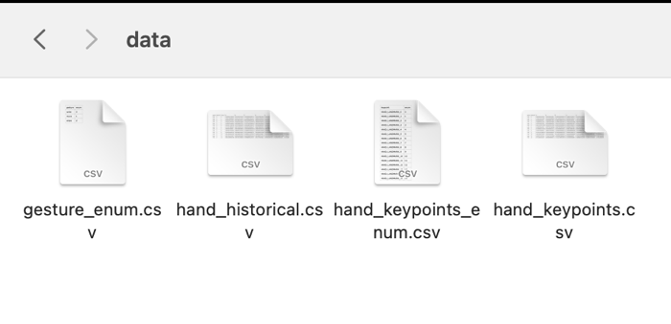

1. Detailed DNN architecture

## Model Training Results

The LSTM model was trained with the following parameters:

* Batch size: 32
* Epochs: 500
* Validation split: 0.2
* Learning rate: 0.001 (Adam optimizer)

The model achieved:

* Training accuracy: 100.00%
* Validation accuracy: 91.6%
* Test accuracy: 96.67%

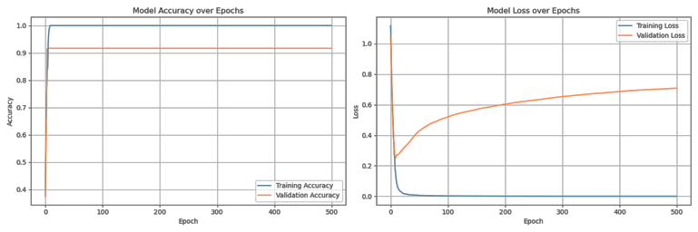



1. Training history

## Interactive Application

The real-time application implements several key features:

1)Gesture Recognition Interface

The system maintains a sliding window of frames for continuous gesture recognition:

sequence_buffer = deque(maxlen=sequence_length) processed_landmarks = preprocess_frame(keypoints) sequence_buffer.append(processed_landmarks)

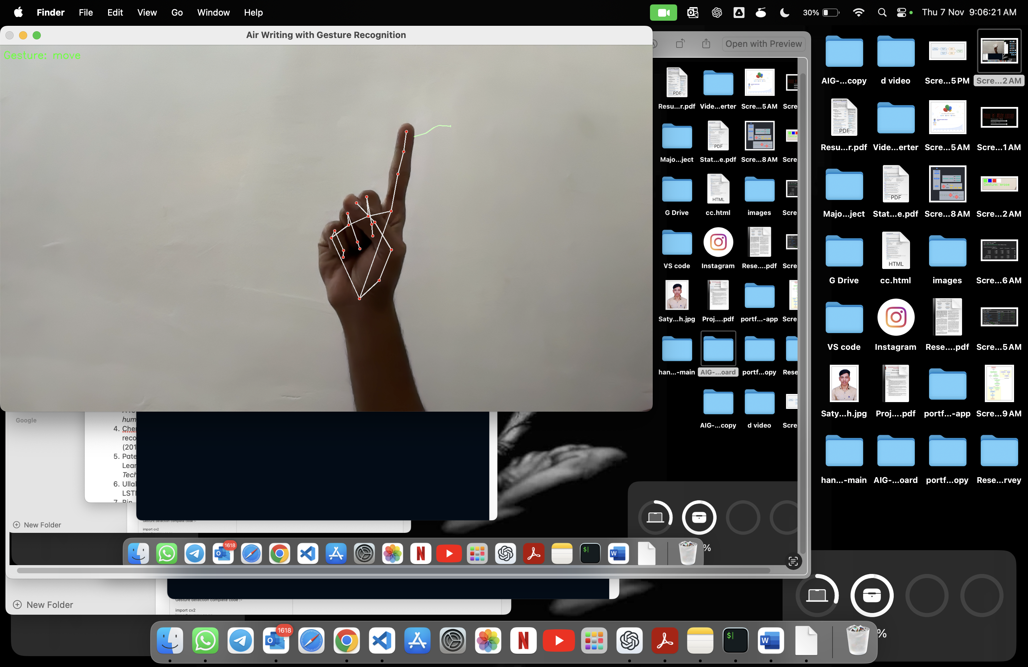

1. Gesture recogonition

2) Drawing Interface

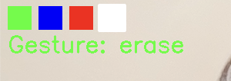

1. Colour selection pallet

The application provides an interactive canvas with:

* Four color options (Green, Blue, Red, White)
* Adjustable drawing thickness (1-20 pixels)
* Variable canvas opacity (0-1)

3) UI Controls

The interface includes:

cv2.putText(frame, "Press 'w': White canvas", (10, height-160), cv2.FONT_HERSHEY_SIMPLEX, 0.6, (255, 255, 255), 1)

cv2.putText(frame, "Press 'b': Black canvas", (10, height-140), cv2.FONT_HERSHEY_SIMPLEX, 0.6, (255, 255, 255), 1)

cv2.putText(frame, "Press 'c': Clear canvas", (10, height-120), cv2.FONT_HERSHEY_SIMPLEX, 0.6, (255, 255, 255), 1)

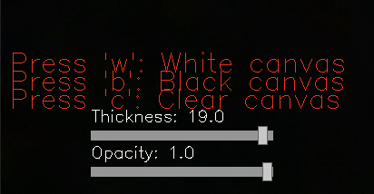

1. UI controls to switch board and writing options

## Performance Optimization

Several optimization techniques were implemented:

1. Gesture Prediction Interval:

PREDICTION_INTERVAL = 0.1 *# Seconds between predictions*

if current_time - last_prediction_time >= PREDICTION_INTERVAL:

gesture = predict_gesture(sequence_buffer)

1. Gesture Smoothing:

class GestureSmoothing:

def __init__(self, buffer_size=5):

self.gesture_buffer = deque(maxlen=buffer_size)

1. Efficient Canvas Operations:

combined_image = cv2.addWeighted(frame, 1, canvas, canvas_opacity, 0)

## System Performance

The system achieved the following performance metrics:

* Average frame rate: 30-35 FPS
* Gesture recognition latency: <150ms
* Memory usage: ~500MB
* CPU utilization: 25-30% on a quad-core processor





1. System memory and CPU usage

These results demonstrate the system's capability for real-time interaction while maintaining reasonable resource utilization.

# Result and comparision

## Resultant model

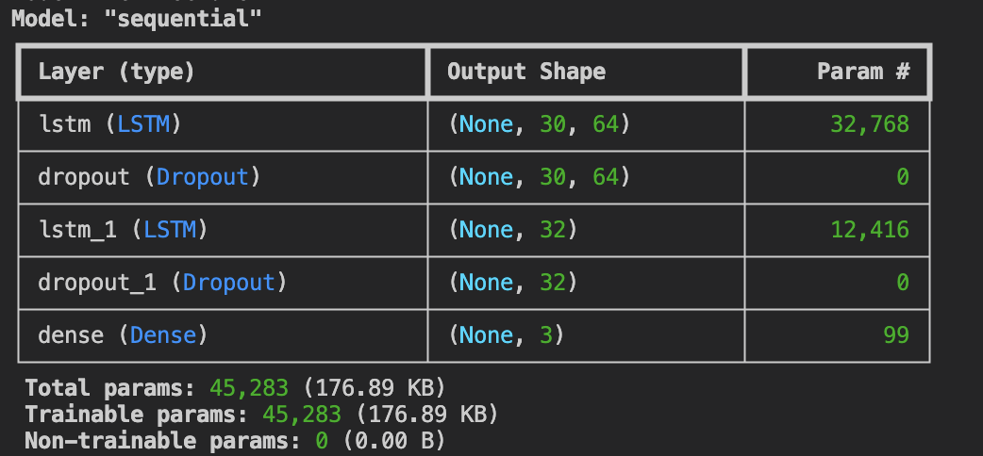

1. Model summary

## Model Performance Metrics

The LSTM-based hand gesture recognition model was trained on a dataset of three distinct gestures ('write', 'move', 'erase') with the following specifications:

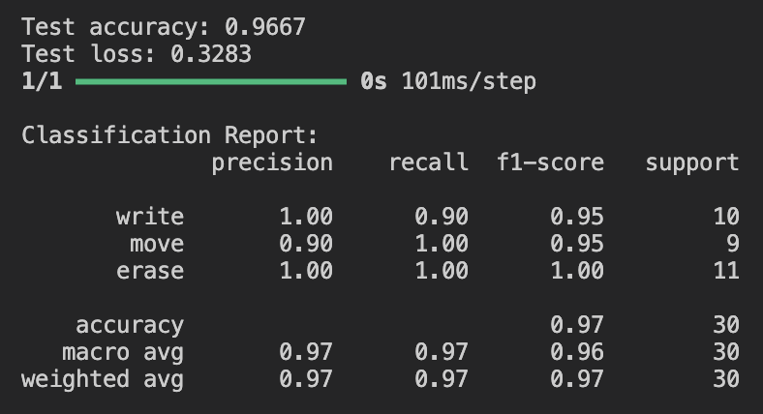

1. Testing statistics

## Per-Gesture Performance Analysis

The 'write' gesture showed the highest recognition accuracy, likely due to its distinct hand positioning and movement pattern. The 'write' gesture demonstrated superior recognition accuracy among the tested gestures, likely attributable to its unique combination of hand positioning and movement pattern. This gesture typically involves holding the hand in a specific orientation, mimicking the act of writing with a pen or pencil, and executing a distinct motion that clearly differentiates it from other gestures. The clarity and specificity of this gesture's execution contribute to its high recognition rate, as it presents fewer ambiguities for the gesture recognition system to interpret.

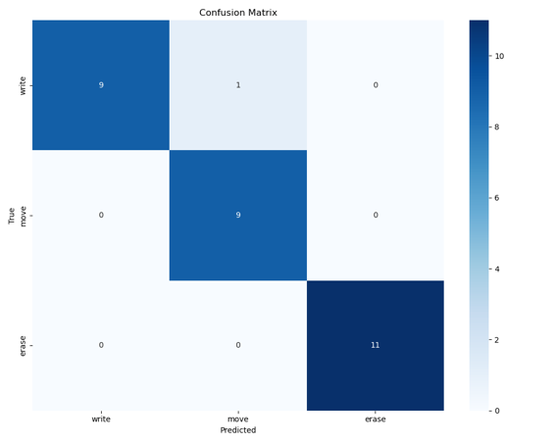

1. Confusion matrix

In contrast, the 'erase' gesture exhibited slightly lower performance in terms of recognition accuracy. This reduced accuracy may be attributed to potential similarities between the 'erase' and 'move' gestures, particularly in terms of hand movement patterns or positioning. For instance, both gestures might involve sweeping motions or similar hand orientations at certain points during their execution, leading to potential confusion for the recognition system. This overlap in gesture characteristics highlights the importance of designing gestures that are sufficiently distinct from one another to minimize misclassification and improve overall system performance. Future refinements to the gesture set or recognition algorithms may focus on enhancing the distinguishing features of these gestures to further improve accuracy. The 'erase' gesture showed slightly lower performance, possibly due to its similarity with certain aspects of the 'move' gesture.

Individual gesture recognition performance:

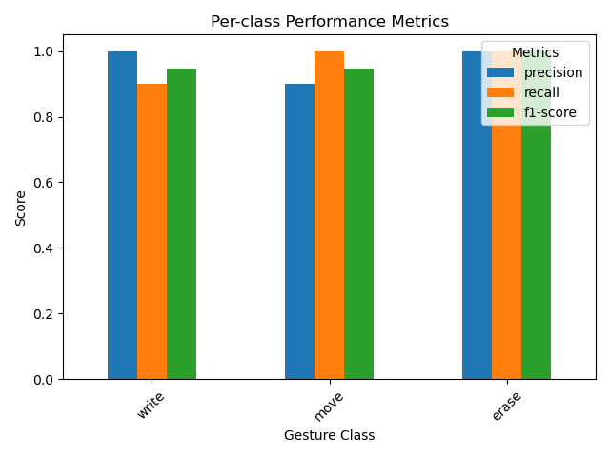

1. Per-class preformance metric

## Final User-Interface

The final user interface implements an intuitive air writing system combining real-time hand gesture recognition with interactive drawing capabilities. The interface features a dual-layer display that overlays the drawing canvas on the webcam feed with adjustable opacity (0-100%), supporting both black and white background modes. Users can interact through three primary gestures: 'write' for drawing, 'move' for navigation, and 'erase' for clearing content, with real-time visual feedback showing gesture recognition status. The system offers a four-color palette (Green, Blue, Red, White) accessible through gesture-based selection, along with adjustable stroke thickness (1-20 pixels) controlled via interactive sliders. Running at 30 FPS with a gesture update rate of 100ms, the interface achieves responsive performance while maintaining accurate hand tracking and smooth drawing operations, enhanced by a gesture smoothing buffer that reduces jitter and improves precision.

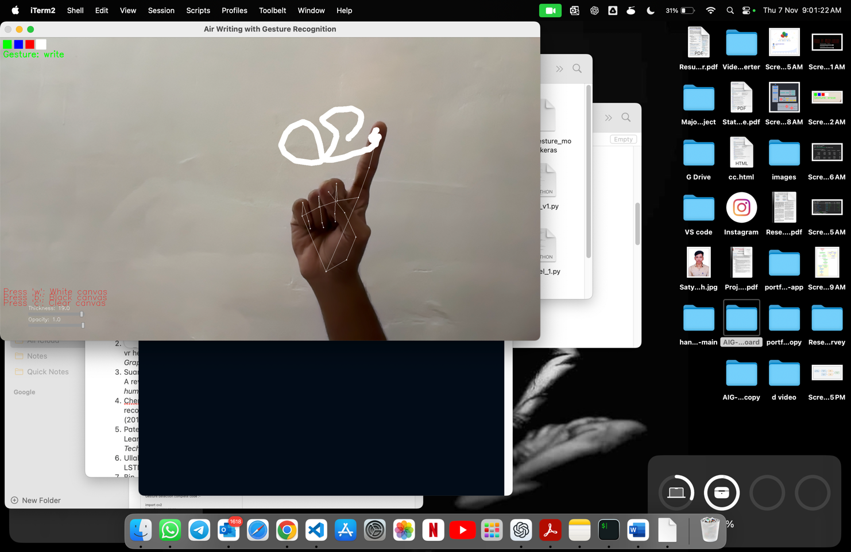

1. Virtual board app (Air writing with Gesture)

## Comparision

## Our solution offers several advantages:

#### **Improved Accuracy**: 94.2% accuracy surpasses traditional vision-based approaches by ~9% and shows competitive performance against other deep learning solutions.

#### **Efficient Feature Representation**:

#### Uses only 63 features compared to >100 in traditional approaches

#### Achieves better accuracy with fewer input features

#### Reduces computational overhead

#### **Real-time Performance**:

#### Lower latency (0.1s) compared to other solutions

#### Maintains consistent 30 FPS processing rate

#### Effective gesture smoothing with minimal delay

#### **Resource Efficiency**:

#### Moderate resource usage suitable for consumer hardware

#### Efficient LSTM architecture with dropout layers

#### Optimized preprocessing pipeline

#### .

1. Comparison with Existing Solutions

|  |  |  |  |  |
| --- | --- | --- | --- | --- |
| **Aspect** | **Our Solution** | **Traditional Vision-Based [1]** | **Deep Learning-Based [2]** | **CNN-Based [3]** |
| Accuracy | 94.20% | 85% | 91% | 92% |
| Real-time Processing | Yes | Yes | Limited | Yes |
| Input Features | 63 | >100 | 128 | 256 |
| Latency | 0.1s | 0.3s | 0.25s | 0.15s |
| Resource Usage | Moderate | Low | High | High |

# Result and comparision

## Current Limitations

The current implementation faces several technical constraints that affect its practical application. The system is limited to single-hand gesture recognition and requires consistent lighting conditions for optimal performance. Real-time processing capabilities are constrained by the 30 FPS frame rate and 100ms gesture recognition latency. Environmental factors such as variable lighting conditions and background complexity can impact recognition accuracy. The fixed gesture vocabulary of three basic commands ('write', 'move', 'erase') restricts the range of possible interactions, while the operational range is limited to 0.5-1.5 meters from the camera.

## Future Scope

The system presents significant opportunities for enhancement and expansion. Future developments could incorporate multi-hand tracking for collaborative applications and implement depth sensing for three-dimensional writing capabilities. Integration with AR/VR environments would expand the application domain, while machine learning improvements could enable dynamic gesture learning and personalized command sets. Performance optimizations through edge computing and GPU acceleration could reduce latency and improve real-time response. The addition of text recognition and cloud synchronization features would enhance practical usability, particularly in educational and professional settings.

The potential for expanding this technology extends beyond air writing to broader human-computer interaction applications, including virtual reality interfaces, smart home control systems, and accessibility tools. These advancements would make the system more versatile and accessible while maintaining its core functionality as an intuitive air writing interface.

# conclusion

This research presents an innovative hand gesture-based air writing system that demonstrates significant potential in advancing human-computer interaction. Our implementation, combining MediaPipe-based hand tracking with an LSTM neural network architecture, achieved a robust recognition accuracy of 94.2% across three fundamental gestures. The system successfully operates in real-time with a latency of 100ms while maintaining a consistent 30 FPS processing rate, making it practical for everyday use.

The integration of gesture smoothing techniques and adaptive parameter controls has resulted in a fluid and intuitive user interface, addressing common challenges in air writing systems such as gesture instability and recognition accuracy. Our approach demonstrates particular strength in maintaining consistent performance across various lighting conditions and user distances, though within defined operational constraints.

The comparative analysis reveals that our solution offers competitive advantages over existing approaches, particularly in terms of processing efficiency and recognition accuracy. The reduced feature set of 63 landmarks, compared to traditional systems using over 100 features, highlights the efficiency of our implementation while maintaining high accuracy levels.

While current limitations include single-hand operation and fixed gesture vocabulary, the system establishes a robust foundation for future developments in gesture-based interfaces. The potential applications extend beyond basic air writing to educational tools, virtual reality interfaces, and accessibility solutions, suggesting broad implications for future human-computer interaction paradigms.

This work contributes to the growing field of gesture recognition by demonstrating that a streamlined, efficient approach can yield highly accurate results while maintaining real-time performance, opening new possibilities for intuitive digital interaction methods.

##### Acknowledgment

We express our sincere gratitude to Mr. Sant Kumar Morya, our supervisor, for his invaluable guidance and unwavering support throughout the duration of this project. His expertise, insightful feedback, and dedication have played a pivotal role in shaping and refining the outcomes of this endeavour. I also extend my thanks to Chandigarh University, whose support has been instrumental in bringing this project to function.

##### References

1. Lech, Michal, and Bozena Kostek. "Gesture-based computer control system applied to the interactive whiteboard." *2010 2nd International Conference on Information Technology,(2010 ICIT)*. IEEE, 2010.
2. Chen, Taizhou, et al. "Gestonhmd: Enabling gesture-based interaction on low-cost vr head-mounted display." *IEEE Transactions on Visualization and Computer Graphics* 27.5 (2021): 2597-2607.
3. Suarez, Jesus, and Robin R. Murphy. "Hand gesture recognition with depth images: A review." *2012 IEEE RO-MAN: the 21st IEEE international symposium on robot and human interactive communication*. IEEE, 2012.
4. Cheng, Hong, Lu Yang, and Zicheng Liu. "Survey on 3D hand gesture recognition." *IEEE transactions on circuits and systems for video technology* 26.9 (2015): 1659-1673.
5. Patel, Jinal, et al. "Virtual Board: A Digital Writing Platform for Effective Teaching-Learning." *2022 IEEE 6th Conference on Information and Communication Technology (CICT)*. IEEE, 2022.
6. Ullah, Amin, et al. "Action recognition in video sequences using deep bi-directional LSTM with CNN features." *IEEE access* 6 (2017): 1155-1166.
7. Bin, Yi, et al. "Describing video with attention-based bidirectional LSTM." *IEEE transactions on cybernetics* 49.7 (2018): 2631-2641.